Entrepreneurs Centers
/ 3.2.2/ Establishment of Entrepreneurs centers

September 28, 2023

DEVELOPMENT OF A MASTER PROGRAMME IN THE MANAGEMENT OF INDUSTRIAL ENTREPRENEURSHIP FOR TRANSITION COUNTRIES
610198-EPP-1-2019-1-ES-EPPKA2-CBHE-JP

On December 27, 2022, by order of the President of the Academy of Sciences of Turkmenistan, the “Entrepreneurship Development Center” was opened at the Technology Center and the Regulations of the Center were developed. In addition to production issues such as Currently, a biofactory is being created for the production of perfumes and cosmetics from medicinal plants, as well as a small enterprise for the production of bioadditives for poultry feed, which will increase resistance to infectious diseases, the Entrepreneurship Center will organize the improvement of the training process based on strengthening the Center’s ties Technologies of the Academy of Sciences of Turkmenistan (CTANT) with government bodies, universities, commercial and non-profit organizations,
- attracting highly qualified specialists and practitioners from the fields of science, education and business,
- increasing the efficiency of using scientific, pedagogical and production personnel, educational, scientific and production potential to improve the process of professional training of entrepreneurs, students, graduate students and doctoral students based on the integration of science, education and production.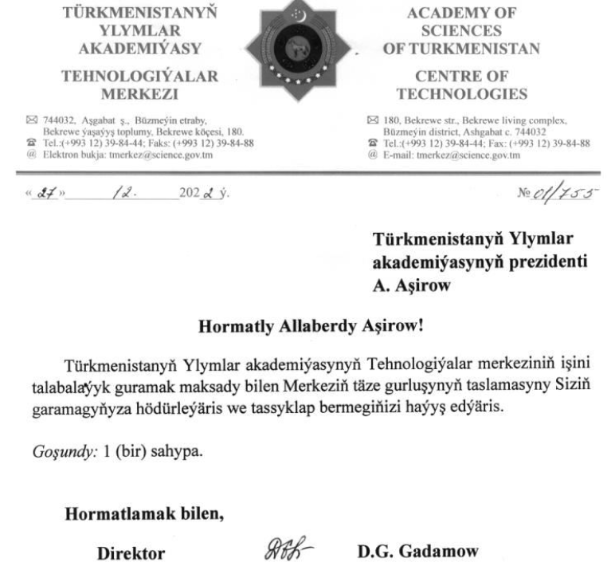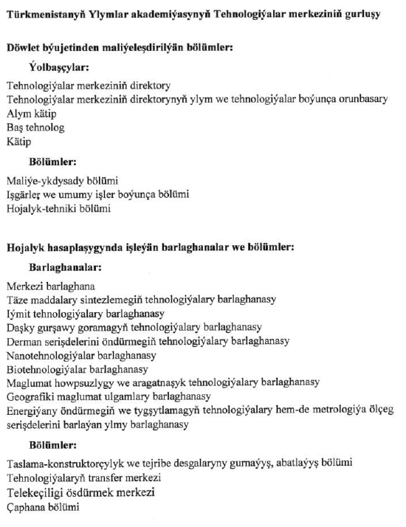

POSITION OF THE CENTER FOR ENTREPRENEURSHIP DEVELOPMENT OF THE CENTER OF TECHNOLOGY OF THE ACADEMY OF SCIENCES OF TURKMENISTAN

The regulation was developed within the framework of the implementation of the international program ERASMUS+ “Development of A Master Programme in the Management of Industrial Entrepreneurship for Transition Countries” (MIETC) and is intended for the development of Entrepreneurship in Turkmenistan and as a basis for the development of individual entrepreneurship concepts.
This provision contains a definition of the goals and objectives of the Entrepreneurship Center, a description of the structure and model of the Entrepreneurship Center, as well as features of interaction between target groups.

1. OBJECTIVES OF THE CENTER

The objectives of the functioning of the entrepreneurial center (hereinafter referred to as the center) are:
- improving the learning process based on strengthening ties between the Center of Technology of the Academy of Sciences of Turkmenistan (CTANT) with government bodies, universities, commercial and non-profit organizations,
- attracting highly qualified specialists and practitioners from the fields of science and education and business,
- increasing the efficiency of using scientific, pedagogical and production personnel, educational, scientific and production potential to improve the process of professional training of entrepreneurs, students, graduate students and doctoral students based on the integration of science, education and production.

2. MAIN OBJECTIVES OF THE CENTER

To achieve these goals, the Center’s activities are aimed at solving the following tasks:
2.1 improving the organization of the preparatory process, strengthening the training of students, doctoral students and entrepreneurs through the development of strategic partnerships with enterprises and organizations;
2.2 coordination of the joint activities of all those wishing to participate in the implementation of educational programs, including its member organizations (institutional structures) and enterprises for training, retraining and advanced training of specialists;
2.3 Assistance in increasing the efficiency of educational and scientific work and introducing their results into production;
2.4 development of research work;
2.5 organization and conduct of practical training for the purpose of professional orientation of students, assistance in employment of graduates - future entrepreneurs.

- FUNCTIONS OF THE CENTER AND ITS PARTICIPANTS

3.1 The Center performs the following main functions:
3.1.1 involving leading practitioners in organizing the process of strengthening its applied focus;
3.1.2 organizes and conducts master classes, lectures, business trainings and group consultations with involved participants, students, graduate students;
3.1.3 organizes review and consultation meetings with stakeholders on the content of educational and methodological materials;
3.1. 4 carries out career guidance work;
3.1. 5 helps in matters of internships and students and graduates in specialized organizations;
3.1. 6 provides support for attracting and implementing research, educational and applied analytical projects;
3.1. 7 organizes scientific and scientific-production seminars, round tables and conferences,
3.1.8 prepares joint scientific publications: monographs, articles, textbooks, seminars.
3.1.9 coordinates and organizes training sessions in the center and in divisions of the enterprise (shops, departments, etc.) or organizations;
3.1.10 contributes to the implementation of coursework, diploma projects (works), dissertations and other projects (educational, research and scientifically specialized areas), scientific work of students on topics related to solving research, experimental and production problems facing the enterprise (organization);
3.1.11 carries out career guidance work among employees of enterprises (organizations) in order to develop entrepreneurial skills;
3.1.12 in collaboration with other organizations, carries out research and experimental production work on the topics of the enterprise (organization) on a contractual basis;
3.1.13 invites experienced specialists of the enterprise (organization) to participate in the educational process on a part-time basis and hourly wage, as well as in scientific seminars;
3.1.14, upon orders from an enterprise (organization), prepares employees, students and graduate students to work there after graduation;

3.2 _ Organizational and professional functions of the Center:
3.2.1 organization and conduct of professional practice for students, graduate students, doctoral students and entrepreneurs on the basis of partner enterprises (under contract);
3.2.2 organization and conduct of scientific internships for graduate students and doctoral students at partner enterprises;
3.2.4 execution /execution custom-made topics from partner companies within the framework of research and dissertations/projects;
3.2.5 participation of enterprises (partners) in the development, review and approval of educational / educational programs, curricula, topics of dissertations and projects in postgraduate and doctoral studies;
3.2.6 use and implementation of the results of research work of graduate students, doctoral students and project executors in the activities of CTAN T;
3. 2.7 other forms of cooperation related to training, educational and scientific activities;
3.2.8 sending, in the prescribed manner, leading production specialists to conduct the educational process and participate in research activities according to joint plans and programs;
3.2.9 allocation of premises for organizing and conducting training sessions, as well as assigning enterprise employees to students during vocational training;

- STRUCTURE OF THE CENTER

4.1 The Center is created as a structural unit on the basis of CTANT.
4. 2 Structurally, the Center may include: the head of the center, offices, managers, tutors, instructors, trainers. It is allowed to attract tutors, instructors, coaches and other categories of contract specialists.
4. 3 The structure and staff of the Center is determined by the staffing table and approved director The functional duties, rights, responsibilities and working conditions of each category of employees must be reflected in job descriptions approved by the director of CTANT.
4. 4 The Center closely cooperates with enterprises, scientific institutes and universities, and also participates in various forms of integration with the business environment (business incubators, co-working centers, educational, research and production complexes, etc.) to develop professional competencies.

5. FINANCIAL SUPPORT FOR THE OPERATION OF THE ENTREPRENEURSHIP CENTER

5.1 The center is financed from the public funds of the institution/organization;
5.2 Funds received in the form of sponsorship from interested parties;
5.3. Funds from various funds and competitive entrepreneurial projects, etc.;
5.4 Funds received from organizing and conducting advanced training courses and other events aimed at popularizing the activities of the Center;
5.5 Funds from interregional institutions for development and support of entrepreneurship;
5.6 Funds from customers training, research and development in the field of technological entrepreneurship;
5.7 Funds received from participation in grant topics and projects initiated by the relevant ministries of the country.

Expected results from the creation of the Entrepreneurial Center
Intermediate results | Final results
1. Feedback from enterprises (organizations) on curricula;  2. Quantity and quality of custom themes from enterprises (organizations);  3. The share of on-site classes conducted systematically on the basis of enterprises (organizations);  4. Number of industrial internships;  5.Number of training seminars held for enterprise employees;  6. Number of round tables held with employers;  7. Number of joint publications by participants;  8. Number of paid trainings, lectures and master classes conducted by representatives of enterprises (organizations);  9. Preparation of business projects. | 1. Increasing the percentage of employment of graduates of the Center’s educational programs;  2. Increasing the percentage of implemented business projects;  3. Increasing the number of executable custom themes;  4.Improving the quality of educational programs.  5. Increase/Improve the level of the business environment in general

Questionarie
Center of Technology of the Academy of Sciences of Turkmenistan
1. Information about a Center
Question | Answer
Name of the Centre | Center for Entrepreneurship Development
Address of the Centre | 744032, Ashgabat c., Bekreve living complex, 2211 (Bekreve) street, 180.
Opening date of the Center | November 8, 2022
Date of modernization (for already operating before the start of the project)
Form of ownership | Authorized center as part of the Technology Center
Funding source | Selgfinanced
Profitability of the Center (в %)
Number of full-time employees by position (to describe) | 4
Availability of Handbook on Establishment of Entrepreneurs Centers
Links to electronic resources | https://scitech.gov.tm/bolumler
Planned period of work (after the project completion)

2. Types of work carried out
(-if the type of work specified in the table was not performed, put a dash,
- if the table does not specify the type of work carried out by your Center, enter it yourself)

Type of work | Number of events for the reporting period, number of listeners | Result | Link  (specify a link to information, analysis, photos, etc., placement on the university's website on the project page)
Organization of events aimed at spreading information among entrepreneurs of the region and conducting career guidance for university graduates in order to popularize the new master program | 2,  26
Availability of a database of enterprises and employers in the region
Constant contact with graduate students of your university and specialized universities in the region
Having your own page on social networks | n/a
Analysis and provision of information to students about the state and trends of the labor market, about the requirements for a job applicant, the formation of a database of vacancies offered by employers | carries out activities for the mass attraction of youth to technological entrepreneurship
Interaction with the employment center of the region | permanent
Interaction with local executive bodies on job search and employment of graduates | Quarter based
Monitoring the needs of market participants in additional training programs | once a year
Conducting master classes by specialists of enterprises – members of basic departments | once a year
Conducting joint career guidance activities with the employer that promote the employment of graduates
Survey of graduate students in order to determine personal, functional and professional competencies in various specialties and motivation for further professional growth (using employer questionnaires)
Organizing and conducting business/economics training courses for industrial enterprises | planned in 2024
Organizing and conducting training courses for entrepreneurs who do not have business and economic competencies | planned to start in 2024
Organizing and conducting courses aimed at improving the pedagogical competence of university teachers
The Open Days | June 12-13
Teaching staff training within the framework of the project
Using the purchased equipment for training

3. Interim (current) results
(-if the type of work specified in the table was not performed, put a dash,
- if the table does not specify the type of work carried out by your Center, enter it yourself)

Indicator | Digital indicator before the opening of the Center | Digital indicator before the opening of the Center (with a link to information, analysis, etc., placement on the university's website on the project page)
Number of upgraded training programs | 1
The number of reviews from enterprises (organizations) that are part of the Center for Educational Programs of the University | 2
The number of commissioned topics from enterprises (organizations) included in the Center (diploma, master's, doctoral works (by profile))
The share of field classes conducted systematically on the basis of enterprises (organizations) that are part of the Center | Banking, management, Entrepreneurship
Number of production practices | 1
The number of author's courses of teaching staff of the department based on the results of industrial practice | 1
The number of training seminars conducted by the Department's employees for employees of enterprises/ entrepreneurs | 1
The number of training seminars/courses organized by the staff of the Center for teachers by entrepreneurs | 1
Number of training seminars/courses for university teachers provided by professors of foreign universities
Number of training seminars/courses for university teachers by the professorship of domestic universities
Number of training seminars/courses conducted for university students
Number of round tables held with employers | 1
Number of joint publications of the Center's participants
Number of lectures by successful entrepreneurs of the region and master classes conducted by representatives of enterprises (organizations)
Number of prepared student prize-winning business projects
Number of prepared student prize-winning business projects, startups in the field of technological entrepreneurship
Number of Open Days
Number of employed students according to the results of Open Days
Number of signed agreements with academic partners
Number of projects/agreements/cooperation implemented jointly with private sector organizations and enterprises
4. Final results of the opening and activity of the Center

Indicators | Digital growth indicator (%)
Share of graduates' employment | 20
Share of advanced training of the teaching staff of the University due to the work of the Center | 10
Share of new disciplines and modernization of existing ones as a result of interaction with the business environment | 15
Share of courses developed in English
Share of students enrolled in the new master program from the total number | 29
Share of new (innovative) educational programs
Share of updated existing educational programs and their improvement as a result of interaction with enterprises in the region
Number of implemented business projects with a business environment | 4
Number of completed works of business contracts | 3
Number of joint agreements with industrial enterprises | 3

5. Sustainability

№ | Type of planned work | Name of the document | Planned implementation period (starting from January 2024 to 2029 and/or beyond) | Indicator of the result, with links to information, analysis, etc., posted on the university's website on the project page
 | science-production and research work | Agreement on implementation Technology for the production of environmentally friendly organo-mineral fertilizers based on local raw materials of Turkmenistan and other | 2024-2025

